**Name:** **Aditya Nalini**

**Registration Number: 19BCE0980**

**Experiment 3: Custom Form**

**Code:**

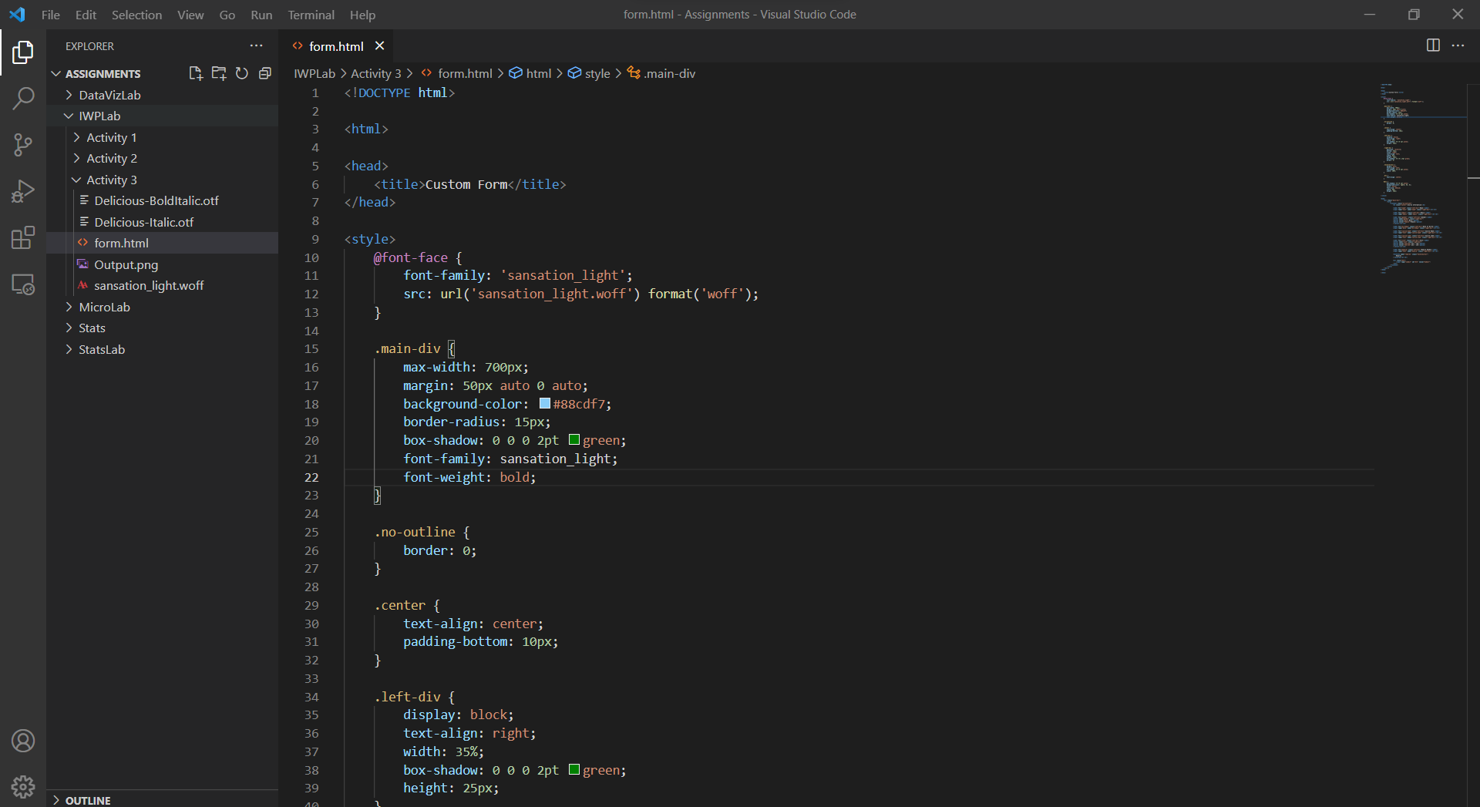

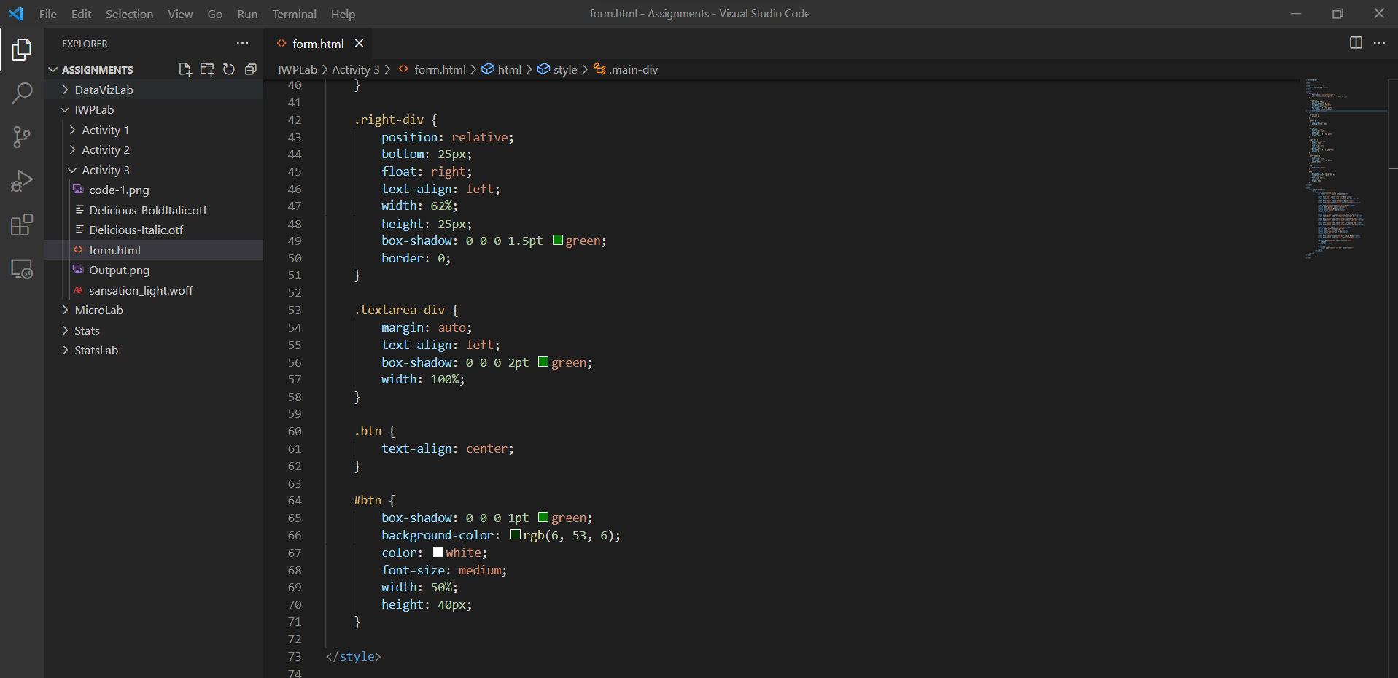

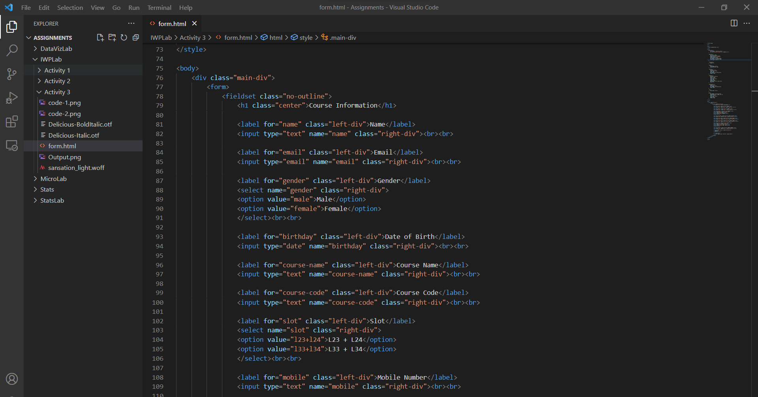

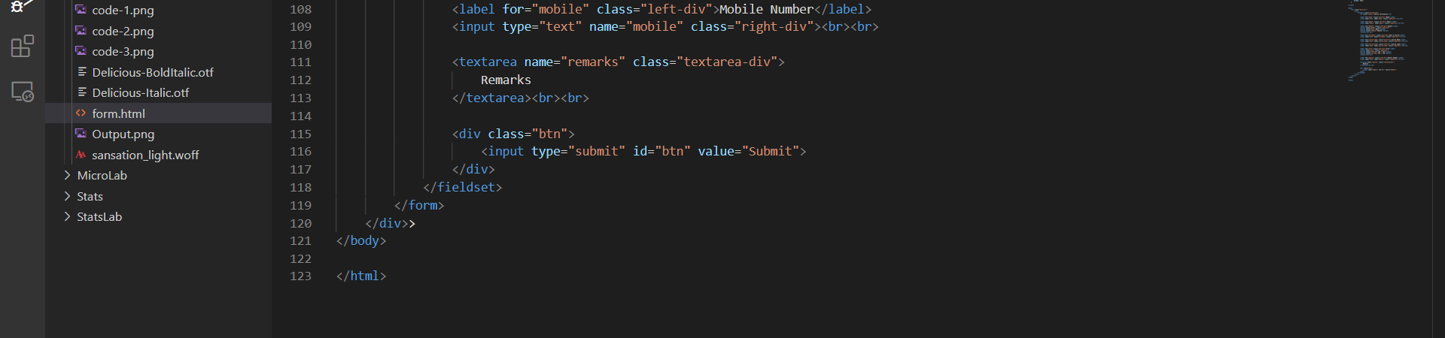

<!DOCTYPE html>

<html>

<head>

<title>Custom Form</title>

</head>

<style>

@font-face {

font-family: 'sansation_light';

src: url('sansation_light.woff') format('woff');

}

.main-div {

max-width: 700px;

margin: 50px auto 0 auto;

background-color: #88cdf7;

border-radius: 15px;

box-shadow: 0 0 0 2pt green;

font-family: sansation_light;

font-weight: bold;

}

.no-outline {

border: 0;

}

.center {

text-align: center;

padding-bottom: 10px;

}

.left-div {

display: block;

text-align: right;

width: 35%;

box-shadow: 0 0 0 2pt green;

height: 25px;

}

.right-div {

position: relative;

bottom: 25px;

float: right;

text-align: left;

width: 62%;

height: 25px;

box-shadow: 0 0 0 1.5pt green;

border: 0;

}

.textarea-div {

margin: auto;

text-align: left;

box-shadow: 0 0 0 2pt green;

width: 100%;

}

.btn {

text-align: center;

}

#btn {

box-shadow: 0 0 0 1pt green;

background-color: rgb(6, 53, 6);

color: white;

font-size: medium;

width: 50%;

height: 40px;

}

</style>

<body>

<div class="main-div">

<form>

<fieldset class="no-outline">

<h1 class="center">Course Information</h1>

<label for="name" class="left-div">Name</label>

<input type="text" name="name" class="right-div"><br><br>

<label for="email" class="left-div">Email</label>

<input type="email" name="email" class="right-div"><br><br>

<label for="gender" class="left-div">Gender</label>

<select name="gender" class="right-div">

<option value="male">Male</option>

<option value="female">Female</option>

</select><br><br>

<label for="birthday" class="left-div">Date of Birth</label>

<input type="date" name="birthday" class="right-div"><br><br>

<label for="course-name" class="left-div">Course Name</label>

<input type="text" name="course-name" class="right-div"><br><br>

<label for="course-code" class="left-div">Course Code</label>

<input type="text" name="course-code" class="right-div"><br><br>

<label for="slot" class="left-div">Slot</label>

<select name="slot" class="right-div">

<option value="l23+l24">L23 + L24</option>

<option value="l33+l34">L33 + L34</option>

</select><br><br>

<label for="mobile" class="left-div">Mobile Number</label>

<input type="text" name="mobile" class="right-div"><br><br>

<textarea name="remarks" class="textarea-div">

Remarks

</textarea><br><br>

<div class="btn">

<input type="submit" id="btn" value="Submit">

</div>

</fieldset>

</form>

</div>>

</body>

</html>

**Output:**

